

Feedback Evaluation
Scan the QR or use link to join

https://forms.office.com/r/2kw7WmQCya
or
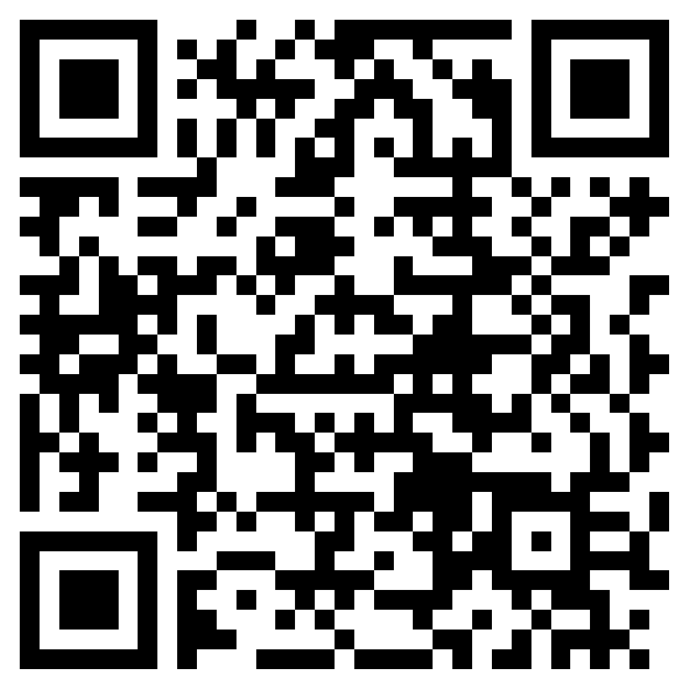
email: registration@eycbrant.ca

